PLEASE REFER TO THE SELLER INFORMATION FLYER FOR INSTRUCTIONS ON DOWNLOADING THE SCOREBOARD APP AND ORDER ENTRY PROCEDURES.
THANK YOU!!

THANK YOU FOR YOUR SUPPORT!

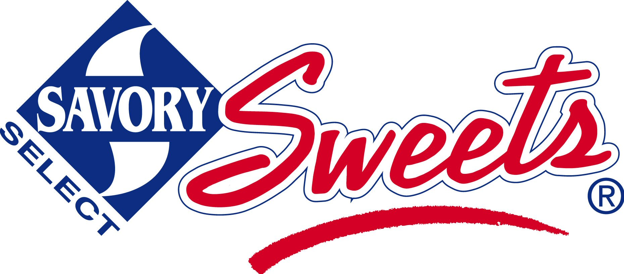

We are pleased to offer Savory Sweets Home Style Cookie Dough and Lava-licious Fudge Cakes, Chocolate Dipped Pretzels and Gourmet Caramel Corn for our current fundraiser!
All of these delicious products are Proudly MADE IN GRAND RAPIDS MICHIGAN!!!

VIRTUAL SALE BEGINS:
VIRTUAL SALE ENDS:
ORDER TO BE DELIVERED WEEK OF: SPECIFIC DAY AND TIME TO BE COMMUNICATED.
Questions? Contact:
PRICES
Home Style Cookie Dough and Gourmet Chocolate Lava Cakes

$19.00 each

PLEASE HELP ME TO REACH
MY PERSONAL GOAL OF: 20 items
TIPS!
Share the brochure in the App with family & friends!
Smile & identify yourself and your group!
Stay safe when selling; never go to a stranger’s house!
Always say “Thank You!”

The money we raise will help us purchase classroom supplies, playground equipment and more!

